3 Year Plan 2024 to 2027:
Tell us what you think

Published: March 2024

What is in this document?

Page number:

What is this document about? 3

A message from Mayor Kirsten
Wise 5

How are we going to pay for the changes? 6

What are some of the changes in
the Plan? 8

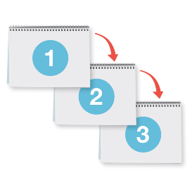
Other things talked about in
the Plan 23

Page number:

Other consultations 25

How to tell us what you think 30

Where to find more information 33

What is this document about?

This Easy Read document is a summary of the 3 Year Plan
2024 to 2027 by Napier City Council.

A summary is:
- shorter than the main document
- tells you the main ideas.

You can find the full Napier City Council 3 Year Plan 2024 to 2027 at this website:

www.sayitnapier.nz
In this document the 3 Year Plan 2024 to 2027 will be called the Plan.

In this document we / our means Napier City Council.

This document will tell you:
- what are some of the changes to the Plan we want to make
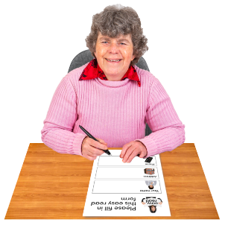
and
- how you can tell us what you think about this.

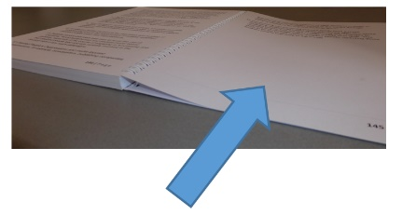
Information on how you can tell us what you think about the Plan is on pages 30 to 32.

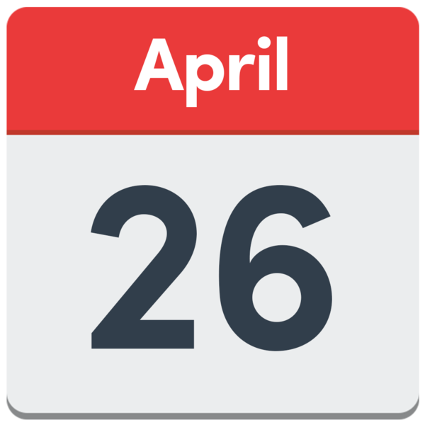
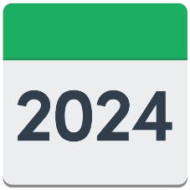
You can tell us what you think by
26 April 2024.

A message from mayor Kirsten Wise

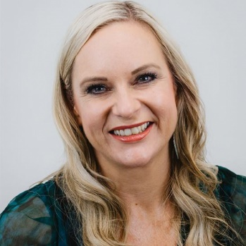
Napier City Council Mayor Kirsten Wise says:

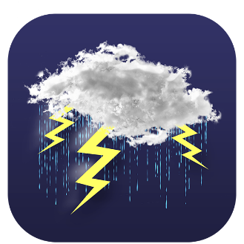
Our 3 Year Plan sets out our programme that will help our community recover from the impacts of the cyclone and puts us on firm foundations for the years ahead.

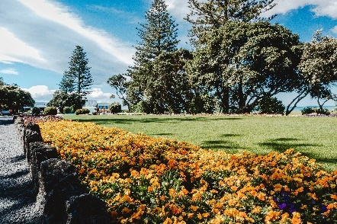
Looking at this draft plan there is an ongoing balancing act required to deliver the best service to our community.

How are we going to pay for the changes?

We are suggesting people pay more rates.

Rates is the money you pay to your Council if you own your home.

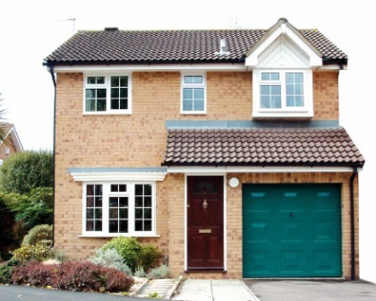
The amount of rates you pay is worked out based on what your property is worth.

Councils use the money from rates
to pay for things like:
      - water pipes / systems
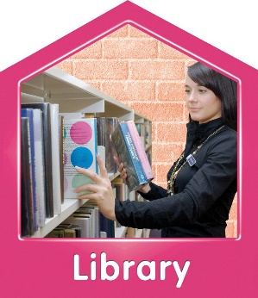
      - roading / footpaths
      - libraries.
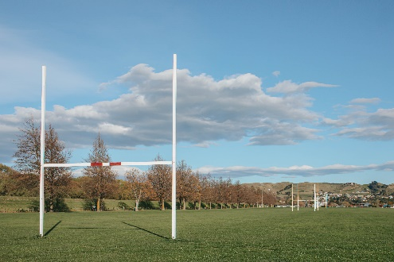
Councils use the money from rates
to pay for things like:
      - parks / playgrounds
      - sports grounds.

We suggest putting up rates by about
24 percent in 2024 to 2025.

This works out to be:
- about 13 and a half dollars each week
- about 7 hundred and 10 dollars each year.
Rates will go up more during the other years of the Plan.

What are some of the changes in the Plan?

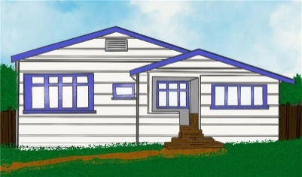
Some of the changes talked about in the Plan are:
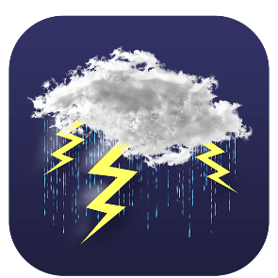
- council housing
- the Disaster Recovery Rate
- investments
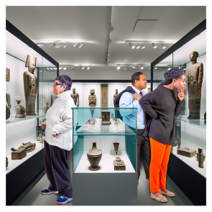
- fees and charges
- the funding for tourist places.
- the offices Napier City Council uses.

We will look at each of these more on pages 10 to 22.

Each of the changes will talk about a preferred option.

A preferred option is the one we would like to do the most.

There is more information about our preferred options in the full Plan.

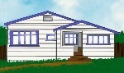
Napier Council housing
$

How much it costs to do Council housing has got a lot bigger.

We have been looking at different ways we can keep doing Council housing.

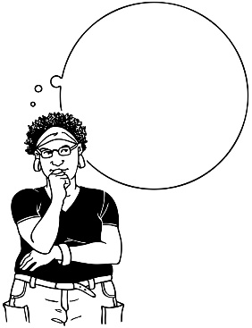
?
We have questions for you to think about.

Should we keep doing Council housing the way it is now by:
- putting up rates
and
- borrowing money?

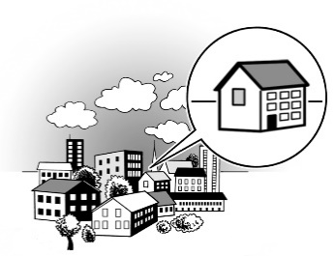
Or should we do:
- council retirement villages only
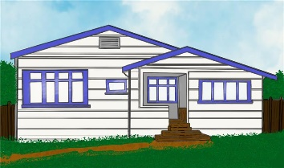
and
- sell our council social housing?

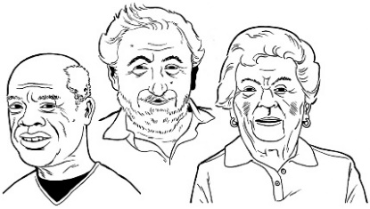
Council retirement villages:
- are places where some older people can live
- can cost less money to live in than some other retirement villages

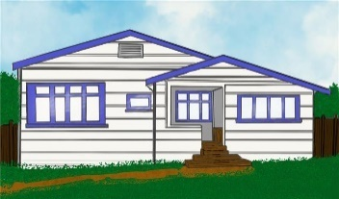
Social housing is houses for people who need somewhere to live that does not cost so much.

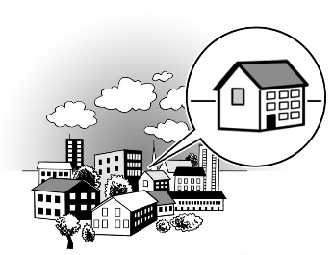
If we choose to do council retirement villages how can we do this in the best way possible?
Our preferred option for this will make rates go up about 12 dollars in
2024 to 2025.

Disaster Recovery Rate
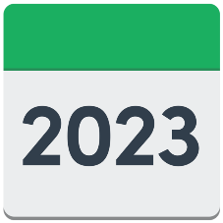
The Disaster Recovery Rate was made in 2023 – 2024.

We want to change the name of the Disaster Recovery Rate to the Resilience Rate.
NAME

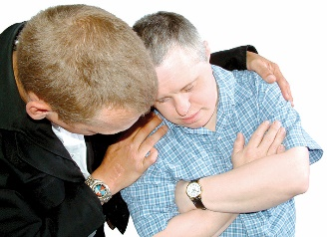
Resilience means being able to
keep doing things when times are hard.

It is being used to fix things after Cyclone Gabrielle.

We need to keep saving money in case another emergency like Cyclone Gabrielle happens.

Our preferred option for this will make rates go up about 86 dollars in
2024 – 2025.

Investments
Here investments means having things that make money like:
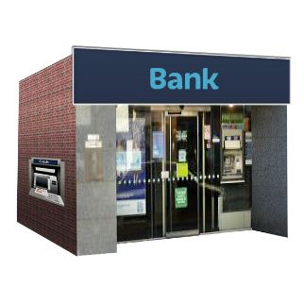
- buildings
- property
- bank accounts.

We have investments worth
1 hundred and 60 million dollars.

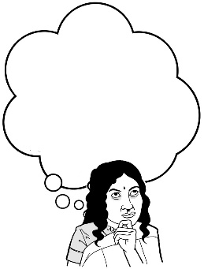
We have been thinking about how to look after these investments.

We would like to make a Council Controlled Trading Organisation.

A Council Controlled Trading Organisation would be a part of the Napier City Council which looks after the investments.

This means we could look after our money better.

Our preferred option for this will make no change to rates in 2024 – 2025.

Fees and charges
We pay for the things we look after by charging you money.

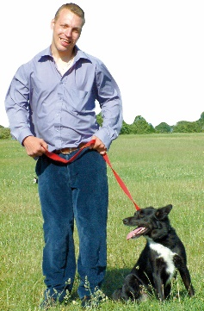
This includes you paying for things like:
- registering your dog
- using Council buildings
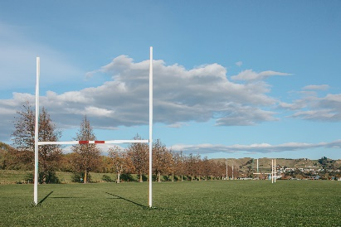
- using Council sports grounds
- going to places like:
- the National Aquarium of New Zealand
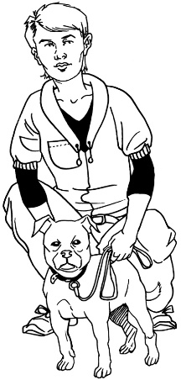
- the Napier Aquatic Centre.

Registering your dog means getting collar tags to show they belong to you.
When we make changes to charges we match it to the Consumer Price Index.

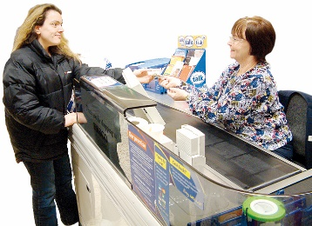
The Consumer Price Index:
- records how much things cost in Aotearoa New Zealand
- shows how prices change.
$

We want to put up some charges more than the Consumer Price Index.

Our preferred option for this will make rates go down about 32 dollars in
2024 to 2025.

Funding for tourist places

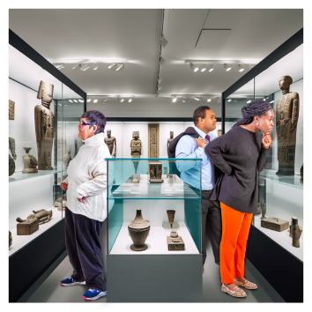
In 2023 we looked at some of our:
- businesses
- tourism places.

We wanted to see if they could work without being given money that is taken from rates.

There are 3 places that are changing to making their own money from
1 July 2024.

We will still own these businesses.

We will support these businesses until they are financially self-sustainable.

Financially self-sustainable means making enough money to pay for all the things a business does.

To support these businesses we are thinking about giving them loans for up to 3 years.

Our preferred option for this will make no change to rates in 2024 to 2025.

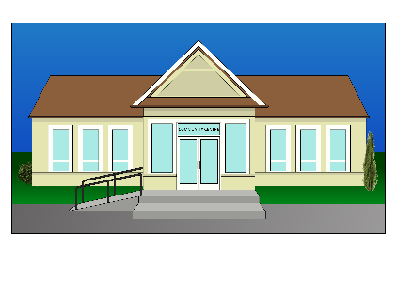
Napier City Council offices

Some of our staff have been working in lots of different buildings.

This happened because we had to move out of the Library Tower on Station Street in 2017.

We were worried the Library Tower building was not safe to be in.

The Library Tower building is owned by the Council.

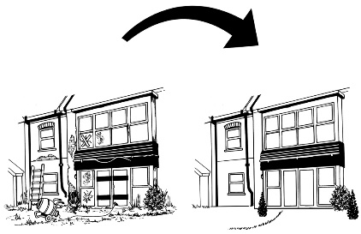
We want to fix the Library Tower so staff can work in there again.

Our preferred option for this will make rates go up about 5 dollars in
2024 to 2025.

Other things talked about in the Plan

In the Plan we talk about other things we are doing.

These include:
- how in 2023 we looked at:
- business places
- tourism places
- our 10-year draft strategy for:
- finance / money
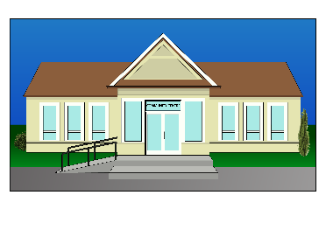
and
- infrastructure.

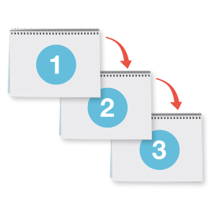
A strategy is a plan to make things happen over a long time.
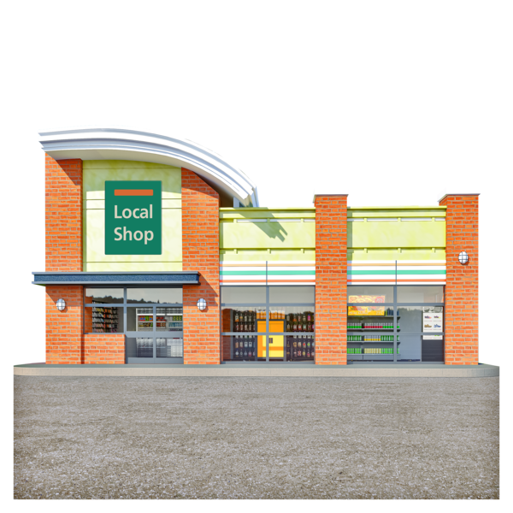

Infrastructure means things:
- buildings
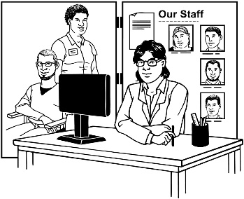
- equipment
- staff.
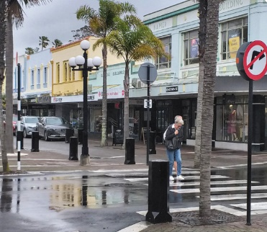

Other things in the Plan we talk about include:
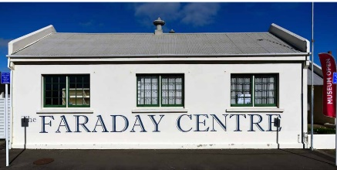
- making Emerson Street look better
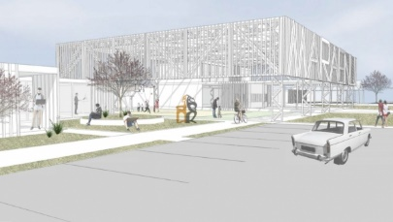
- Faraday Museum of Technology
- Te Pihinga community area
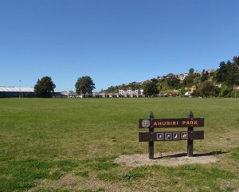
- making the new Ahuriri Regional Park.

Other consultations

We are doing 3 other consultations at the same time as looking at the Plan.

A consultation means:
- talking about something with lots of different people
and
- getting lots of different ideas.

The 3 consultations we are doing are:
- Significance and engagement policy
- Revenue and financing policy
- Financial contributions policy.

A policy is a set of rules that supports the decisions being made by:
- the Government
- a council
- an organisation.

You can tell us what you think about the changes we want to do to these policies.

Significance and engagement policy

This policy is about:
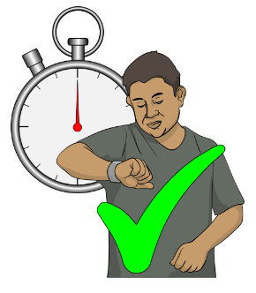
- the ways we talk to our community about our decisions
and
- when we do this.

We want to make some changes to the policy.

Revenue and financing policy

This policy talks about how we:
- get money
and
- spend money.

We want to change how we get money for some of the things we do.

Financial contributions policy
This policy is about how property developers give us money to do things in Napier.

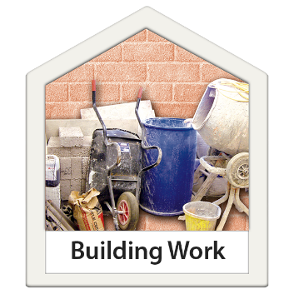
Property developers are business people who:
- do things with the land they own
- build things on the land they own.

We want to change how things are said in this policy.

This is so it is like the words in the District Plan.

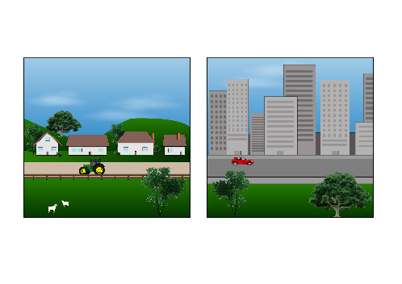
A District Plan is a plan for the things that are done in the areas all around a:
- city
- town.

How to tell us what you think

You can tell us what you think about the 3-Year Plan 2024 – 2027 at this website:

www.sayitnapier.nz

You can get a paper submission form to fill out at:
- the Napier City Council customer service centre on Hastings Street
- Napier Library
- Taradale Library.

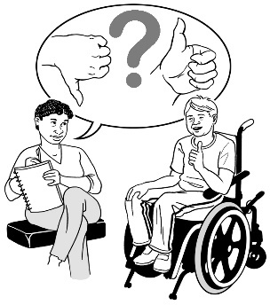
We are holding drop-in sessions to talk about the Plan.

A drop-in session is where you can go to talk to someone without:
- making an appointment
- it being an official meeting.

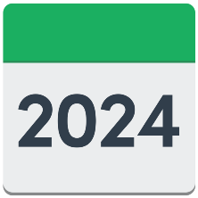
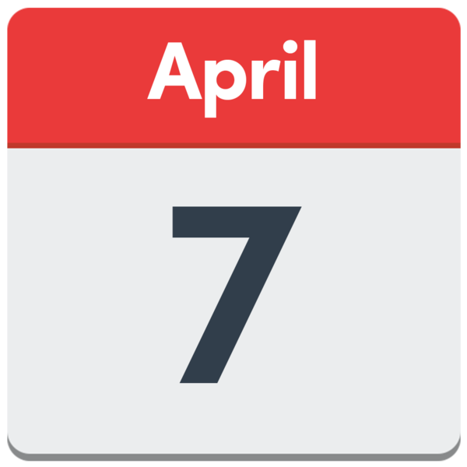
The first drop-in session is:
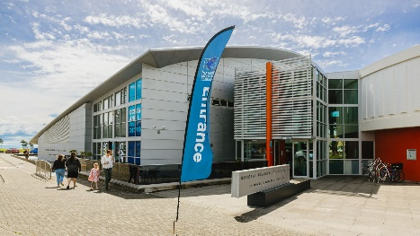
- on Sunday 7 April 2024
- at the National Aquarium of New Zealand
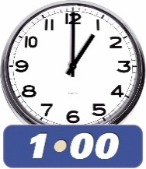
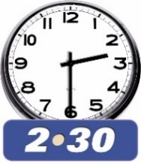
- from 1 pm to 2:30 pm in the afternoon.

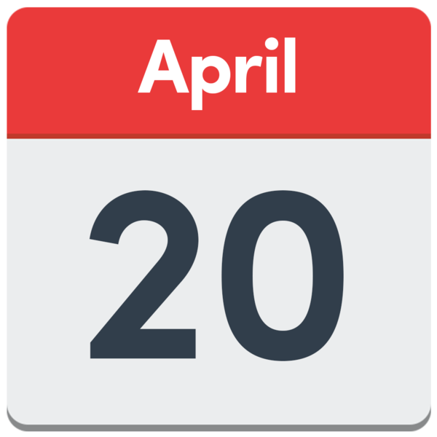
The second drop-in session is:
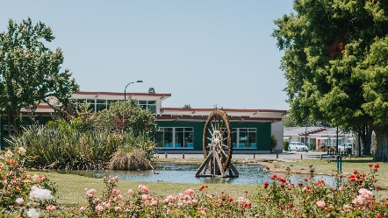
- on Saturday 20 April 2024
- at the Taradale library
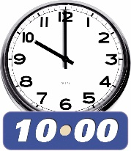
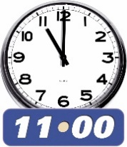
- from 10 am to 11 am in the morning.

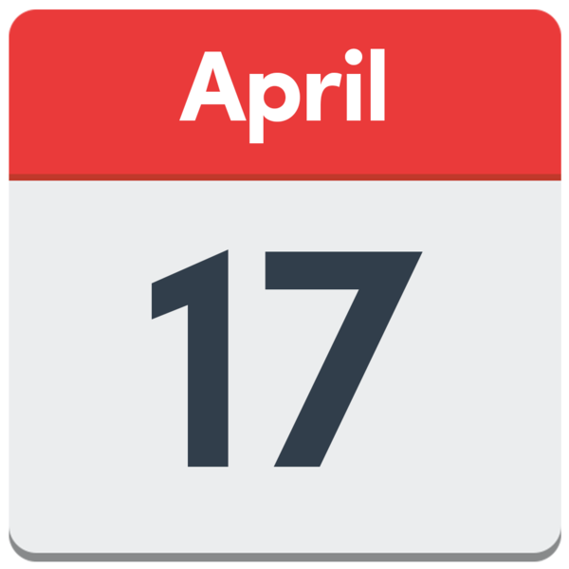
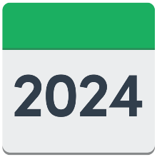
We are holding a public meeting:
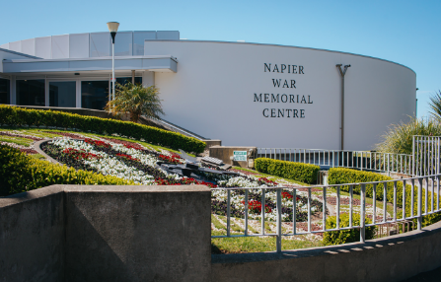
- on Wednesday 17 April 2024
- at the Napier War Memorial Centre
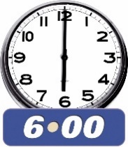
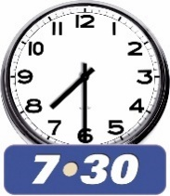
- from 6 pm to 7:30 pm in the evening.

Where to find more information

You can find the full Napier City Council 3 Year Plan 2024 to 2027 at this website:

www.sayitnapier.nz

You can find more information or contact the Council by

Website: www.napier.govt.nz

Email: info@napier.govt.nz

Phone: 06 835 7579

Office: 215 Hastings Street
Napier

This information has been written by Napier City Council – Te Kaunihera o Ahuriri.

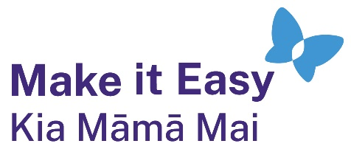
It has been translated into Easy Read by the Make it Easy Kia Māmā Mai service of People First New Zealand Ngā Tāngata Tuatahi.
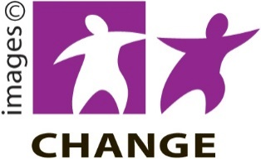
The ideas in this document are not the ideas of People First New Zealand Ngā Tāngata Tuatahi.

Make it Easy uses images from:

- Changepeople.org

            - Photosymbols.com

- SGC Image Works
- Huriana Kopeke-Te Aho
- T. Wood.
All images used in this Easy Read document are subject to copyright rules and cannot be used without permission.

