Rating Policy
Approved by | Council
Department | Finance
Original Approval Date | 11 February 2021 | Review Approval Date
Next Review Deadline | 11 February 2024 | Document ID | TBA
Relevant Legislation | Local Government Act 2002,  Local Government (Rating) Act 2002
NCC Documents Referenced | Revenue & Financing Policy  Funding Impact Statement  Rates Remission Policy  Rates Postponement Policy  Reviewed and amended in preparation for the Long Term Plan 2021-2031.

Purpose
To assist Council in setting rates as specified within the requirements of the Local Government Act 2002 (LGA) and the Local Government (Rating) Act 2002 (LGRA).
This Policy is to be read in conjunction with the Revenue and Financing Policy, Rates Remission and Postponement Policy and Funding Impact Statement.
The Council must complete the following to set a lawful rate.
- Analysis as per s.101(3) of the Local Government Act 2002
- Adopt a Revenue and Financing Policy
- Adopt a Funding Impact Statement
- Adopt an Annual or Long Term Plan
- Adopt a rates resolution consistent with the actions described above.
Note: to maintain rating consistency, unless otherwise stated, adopted amendments made during any rating year to this policy will only become effective with the adoption of the following Annual Plan or Long Term Plan.

Policy
- General Rates
General Rates are used to fund both operating and capital expenditure. They fund the remaining costs of Council operations after all other sources of funding have been applied.
General Rates are assessed through a combination of a Uniform Annual General Charge (UAGC) and a rate in the dollar based on land value.
The amount of the UAGC is set to ensure that the total (excluding water and wastewater rates) uniform (or fixed) rates will be between 20% to 25% of total rates that are to be collected.
The General Rate is set differentially using matters as prescribed in Schedule 2 of the LGRA, and as listed in the Funding Impact Statement. The LGRA Schedule 2 allows councils to set a General Rate based on each of these matters.
  - General rate differentials
Rating Units assessed for the General Rate are categorised into one of four differential categories:
- Residential/Other
- Commercial & Industrial
- Rural
- Rural Residential
Residential/Other
Any property that is not defined as Commercial & Industrial, Rural Residential or Rural.
Commercial & Industrial
Any property that is in a commercial or industrial zone under the District Plan or used for any business activities, except properties categorised as rural or consented for residential use, will be rated as commercial and industrial properties.
Commercial and industrial activities include, but are not restricted solely to:
- Rural and other similar activities such as transport, supplies, packhouses and wineries servicing multiple clients
- Professional offices, surgeries etc.
- All retail, wholesale merchandising activities
- All forms of manufacturing and processing
- Bars, restaurants, cafes and other service activities
- Storage facilities
- Hotels, motels, B & B’s and other short-term accommodation providers
- Tourism operations
- Care facilities operated for profit

Rural Residential
Any rating unit that would otherwise be classified as Residential, but is not connected or able to be connected to both the city water system and the city sewerage system.

Rural
Any rating unit with an area of 5 Hectares or more that is used predominantly for land based agricultural or farming activities.

Differentials
A review of the Revenue & Financing Policy was conducted with adoption occurring in February 2021. New differentials were introduced. Based on the review, the following are the differentials to be applied based on the land value of properties in each differential category.
Differentials | Group / Code | Differential Rate
Residential / Other | 1 | 100%
Commercial & Industrial | 2 | 260%
Rural | 3 | 85%
Rural Residential | 4 | 90%

Due to significant increases being experienced for certain property types, General Rate differentials will be phased in over 3 years from the start of the 2021/22 ratings year. The calculation is based on the difference between the old differential (as defined in the 2020/21 Annual Plan) and the target differential, split into 3 equal stages. The schedule for phasing is as follows:

Old Differentials | Old Code | Old Differential Rate | New Differential Rate | New Code | Differential Rate | 2021/22 | 2022/23 | 2023/24
City Residential | 1 | 100.00% | Residential/Other | 1 | 100.00% | 100.00% | 100.00% | 100.00%
Commercial & Industrial | 2 | 268.09% | Commercial & Industrial | 2 | 260.00% | 265.39% | 262.70% | 260.00%
Miscellaneous | 3 | 100.00% | Residential/Other | 1 | 100.00% | 100.00% | 100.00% | 100.00%
Miscellaneous | 3 | 100.00% | Commercial & Industrial | 2 | 260.00% | 153.33% | 206.67% | 260.00%
Miscellaneous | 3 | 100.00% | Rural | 3 | 85.00% | 95.00% | 90.00% | 85.00%
Miscellaneous | 3 | 100.00% | Rural Residential | 4 | 90.00% | 96.67% | 93.33% | 90.00%
Ex City Rural | 4 | 63.47% | Residential/Other | 1 | 100.00% | 75.65% | 87.82% | 100.00%
Ex City Rural | 4 | 63.47% | Rural Residential | 4 | 90.00% | 72.31% | 81.16% | 90.00%
Ex City Rural | 4 | 63.47% | Rural | 3 | 85.00% | 70.65% | 77.82% | 85.00%
Other Rural | 5 | 63.47% | Residential/Other | 1 | 100.00% | 75.65% | 87.82% | 100.00%
Other Rural | 5 | 63.47% | Rural Residential | 4 | 90.00% | 72.31% | 81.16% | 90.00%
Other Rural | 5 | 63.47% | Commercial & Industrial | 2 | 260.00% | 128.98% | 194.49% | 260.00%
Other Rural | 5 | 63.47% | Rural | 3 | 85.00% | 70.65% | 77.82% | 85.00%
Bay View | 6 | 72.80% | Residential/Other | 1 | 100.00% | 81.87% | 90.93% | 100.00%
Bay View | 6 | 72.80% | Commercial & Industrial | 2 | 260.00% | 135.20% | 197.60% | 260.00%
Bay View | 6 | 72.80% | Rural Residential | 4 | 90.00% | 78.53% | 84.27% | 90.00%

The purpose of the differentials applied to the General Rate is to ensure that the amount payable by groups of ratepayers reflects Council’s assessment of the relative benefit received and share of costs those groups of ratepayers should bear based on the principles outlined in the Revenue and Financing Policy.
Notes on allocation of properties into differential categories
Rating units which have no apparent land use (or are vacant properties) will be placed in the category which best suits the zoning of the property under the district plan except where the size or characteristic of the property suggest an alternative use.
To avoid doubt where a rating unit has more than one use the relevant predominant use will be used to determine the category. The predominant use relates to the main productive activity rather than just to the land area. Where there is uncertainty the land will be categorised into the highest rated category.
Subject to the right of objection as set out in Section 29 of the Local Government (Rating) Act 2002, it shall be at the sole discretion of the Council to determine the use or predominant use of all separately rateable properties in the district.
  - Uniform Annual General Charge (UAGC)
Council’s Uniform Annual General Charge is set at a level that enables all Targeted Rates that are set on a uniform basis as a fixed amount, excluding those related to Water Supply and Sewage Disposal, to recover between 20% and 25% of total rates.
The charge is applied to each separately used or inhabited part of a rating unit.
- Targeted Rates
Targeted Rates are charged to fund both operating and capital expenditure. They are charged where Council considers it desirable to separate out the funding of an activity. They are charged to rating units including those units that are separately inhabited which have access to or are deemed to benefit from the service provided. Targeted rates are a funding mechanism that may be charged for activities deemed to have either a high public or a high private good to identified properties, an area of the city or the city as a whole.
Some targeted rates are applied differentially using either land or capital values, however most targeted rates are applied on a uniform basis (same amount or rate in the dollar).
Water
  - Fire Protection Rate
This rate recovers a portion of the net costs of the water supply systems before the deduction of water by meter income.
The Fire protection targeted rate is based on the Capital Value of properties connected to, or able to be connected to, the Napier City Council water supply systems.
This rate is differentially applied, in recognition that the carrying capacity of water required in the reticulation system to protect commercial and industrial properties is greater than that required for residential properties. The rate is further differentiated where a property is not connected but is within 100 metres of a water supply system. 50% of the base rate for each differentiated category applies for each property not connected but located within 100 metres of the systems.
Differentials | Connected (%) | Not connected but within 100m (%)
Central Business District and Fringe Area | 400% | 200%
Suburban Shopping Centres, Hotels and Motels and Industrial rating units outside of the CBD | 200% | 100%
Other Rating Units connected to or able to be connected to the Council water supply systems | 100% | 50%

  - Water Rate
These rates recover the balance of the total net cost of the water supply systems after allowing for revenue collected from the Fire Protection Targeted Rate and the Water by Meter targeted rate.
The targeted rates are differentially applied and are a fixed amount set on a uniform basis, applied to each Separately Used or Inhabited Part of a Rating Unit connected to or able to be connected to, the Council’s water supply system.
The differential categories for the water rates are:
- Connected – any Rating Unit that is connected to a Council system
- Service available – any Rating Unit that is not connected to a Council system but is within 100 metres of such system (charged 50% of the targeted rate for connected properties)
Differentials | Connected (%) | Not connected but within 100m (%)
Rating Units connected to or able to be connected to the Council water supply systems | 100% | 50%

  - Stormwater Rate
The primary beneficiary of storm water assets are those properties that have a hard surface. There is a strong relationship between Capital Value and the hard surface area of a property.
This rate recovers the cost of storm water asset management. The Stormwater Rate is based on the Capital Value of Residential and Commercial & Industrial properties within the recognised urban limit (i.e. non-rural property as defined under the District Plan).
Rural properties are exempted.
The differential categories for Stormwater Rates are:
Differentials | Differential Rate within urban limits
Residential / Other | 100%
Commercial & Industrial | 250%
Rural Residential | 100%

  - Sewerage Rate
This rate recovers the net cost of the waste water activity.
The Sewerage targeted rate is applied differentially as a fixed amount and is set on a uniform basis. It is applied to each separately used or inhabited part of a rating unit connected to, or able to be connected to, the Sewerage System.
A differential of 50% of the rate applies to each rating unit not connected but located within 30 metres of the system.
Differentials | Connected (%) | Not connected but within 30m (%)
Rating units connected to or able to be connected to the City Sewerage Systems | 100% | 50%

  - Bay View Sewerage Connection Rate
The Bay View Sewerage Scheme involves reticulation and pipeline connection to the City Sewerage System. Prior to 1 November 2005, property owners could elect to connect either under a lump sum payment option, or by way of a targeted rate payable over 20 years.
The Bay View Sewerage Connection targeted rate is a fixed amount set on a uniform basis. It is applied to each separately used or inhabited part of a rating unit connected to the Bay View Sewerage Scheme, where the lump sum payment option was not elected.
The rate applies from 1 July following the date of connection for a period of 20 years, or until such time as a lump sum payment for the cost of connection is made.
The category of rateable land for setting the targeted rate is defined as the provision of a service to those properties that are connected to the sewerage system, but have not paid the lump sum connection fee.
Refuse & Recycling
  - Refuse Collection and Disposal Rate
This rate recovers the cost of the kerbside refuse collection service, including an allocation of the cost of Council support services.
The Refuse Collection and Disposal targeted rate of a fixed amount is set on a uniform basis. It is applied to each separately used or inhabited part of a rating unit for which a rubbish collection service is available and is multiplied by number of times each week the service is provided. Rating units which Council officers determine are unable to practically receive the Council service and have an approved alternative service will be charged the waste service charge that excludes the approved alternative service.
  - Kerbside Recycling Rate
This rate recovers the net cost of the kerbside recycling collection service, including an allocation of the cost of Council support services.
The Kerbside Recycling targeted rate of a fixed amount is set on a uniform basis. It is applied to each separately used or inhabited part of a rating unit for which the kerbside recycling collection service is available. Rating Units which Council officers determine are unable to practically receive the Council service and have an approved alternative service will be charged the waste service charge that excludes the approved alternative service.
Off Street Car Parking Rates
  - CBD Off Street Car Parking Rate
This rate is used to provide additional off street car parking in the Central Business District. Those commercial rating units in the mapped areas identified as the Central Business District Off Street Car Parking 100% and 50% Parking Dispensation areas are charged the CBD Off Street Parking targeted rate based on land value. This rate is set on a differential basis as follows:
Differentials | %
Properties where council provides additional parking due to the property receiving a 100% parking dispensation | 100%
Properties where council provides additional parking due to the property receiving a 50% parking dispensation. | 50%

Refer Council maps:
- CBD Off Street Car Parking – 100% Parking Dispensation Area
- CBD Off Street Car Parking – 50% Parking Dispensation Area
  - Taradale Off Street Car Parking Rate
This rate is used to provide additional off street car parking in the Taradale Suburban Commercial area.
Those commercial rating units in the Taradale Suburban Commercial area only are charged the Taradale Off Street Parking targeted rate based on land value and set on a uniform basis.
  - Suburban Off Street Car Parking Rate
This rate is used to provide additional off street car parking at each of these areas served by Council supplied off street car parking, and to maintain the existing off street car parking areas.
Those commercial rating units in suburban shopping centres and those commercial properties located in residential areas which are served by Council supplied off street car parking are charged the Suburban Shopping Centre Off Street Parking targeted rate based on land value and set on a uniform basis.
Promotion Rates
  - CBD Promotion Rate
This rate recovers at least 70% of the cost of the promotional activities run by Napier City Business Inc. The remainder is met from general rates to reflect the wider community benefit of promoting the CBD to realise its full economic potential.
Each commercial and industrial rating unit situated within the area as defined on Council map “CBD Promotion Rate Area” are charged the CBD Promotion targeted rate based on land value and set on a uniform basis.
  - Taradale Promotion Rate
This rate recovers the full cost of the Taradale Marketing Association’s promotional activities. All rating units in the Taradale Suburban Commercial area are charged the Taradale Promotion targeted rate based on land value and set on a uniform basis.
Other Rates and Charges
  - Swimming Pool Safety Rate
This rate recovers the cost of pool inspections and related costs to ensure owners meet the legal requirements of the Building Act 2004 and Building (Pools) Amendment Act 2016. A targeted rate of a fixed amount set on a uniform basis, applied to each rating unit where a residential pool or small heated pool (within the meaning of the Building (Pools) Amendment Act 2016) is subject to a 3 yearly pool inspection.
  - Water By Meter Charges
This rate applies to all with a water meter and is charged based on a scale of charges as shown on the schedule of indicative rates each year.
Where any rating unit is suspected to have above average water usage Council officers may require that a water meter is installed and excess usage is charged based the water by meter targeted rate.
The rate based on actual water use above the first 300m³ per SUIP per annum applies to select metered properties.
Targeted Rates Note:
For the purposes of Schedule 10, clause 15(4)(e) or clause 20(4)(e) of the Local Government Act 2002, lump sum contributions will not be invited in respect of targeted rates, unless this is provided within the description of a particular targeted rate.

- Separately Used or Inhabited Parts of a Rating Unit Definition
  - Definition
For the purposes of the Uniform Annual General Charge and all uniform (or fixed value) Targeted Rates, a separately used or inhabited part of a rating unit is defined as: Any part of a rating unit that is, or is able to be, separately used or inhabited by the owner or by any other person or body having the right to use or inhabit that part by virtue of a tenancy, lease, licence or other agreement.
This definition includes separately used parts, whether or not actually occupied at any particular time, which are provided by the owner for rental (or other forms of occupation) on an occasional or long term basis by someone other than the owner.
Examples of separately used or inhabited parts of a rating unit include:
- For residential rating units, each consented supplementary unit is considered a separately used or inhabited part. Each situation is assessed on its merits.
- Residential properties, where a separate area that is available to be used as an area independent to the rest of the dwelling is used for the purpose of operating a business, such as a professional practice, dedicated shop\display area or trade workshop. The business area is considered a separately used or inhabited part.
- For commercial or industrial properties, two or more different businesses operating from or making separate use of the different parts of the rating unit. Each separate business is considered a separately used or inhabited part. A degree of common area would not necessarily negate the separate parts.
- Where a single business comprises multiple buildings, or multiple floors of a single building, each building or floor of a multi-story building is deemed to constitute a separate part (SUIP).
These examples are not inclusive of all situations.

- Maps
  - CBD Promotion Rate Area
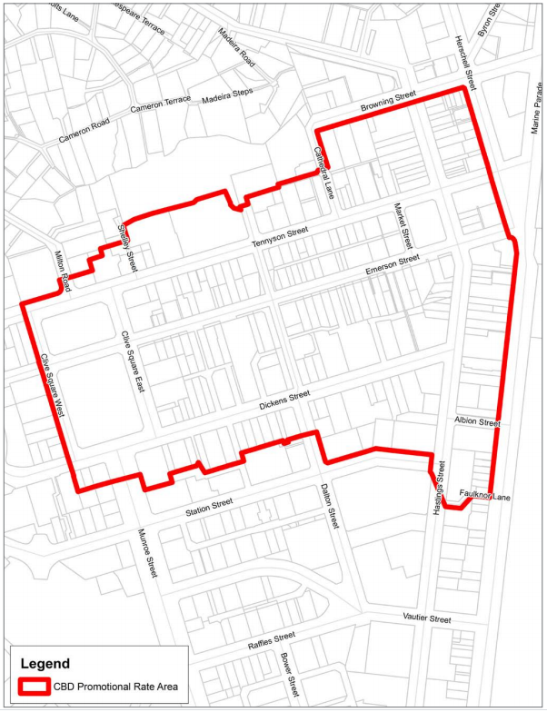

  - CBD Off Street Parking
100% Parking Dispensation Area
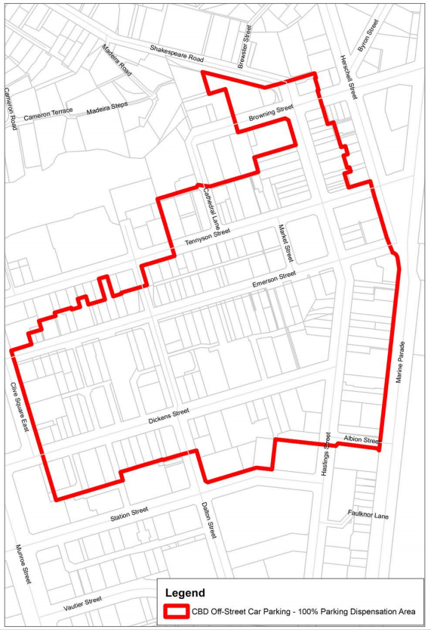

50% Parking Dispensation Area
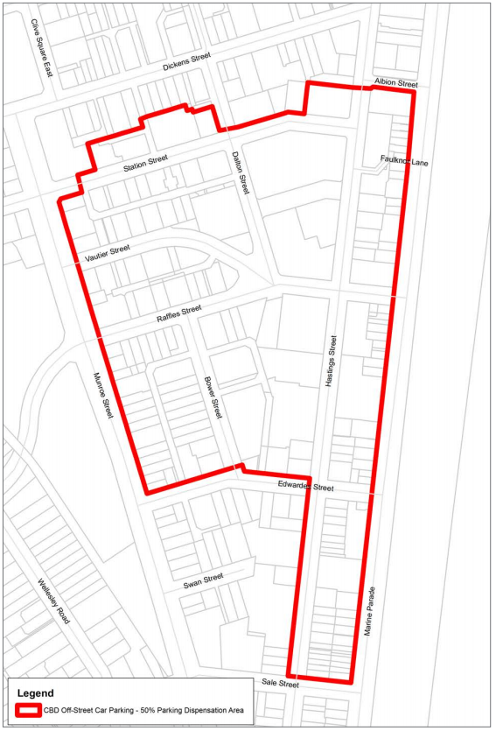

  - CBD Fire Protection Area
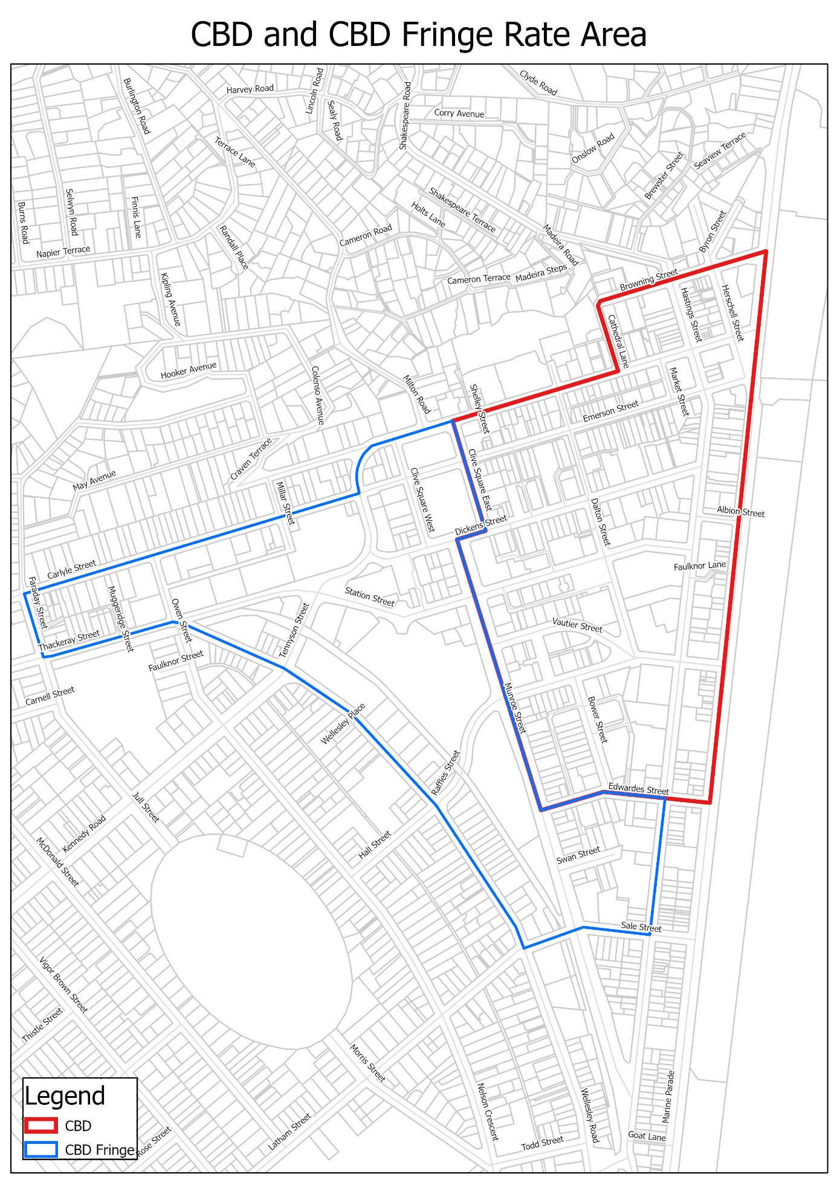

  - Stormwater Coverage
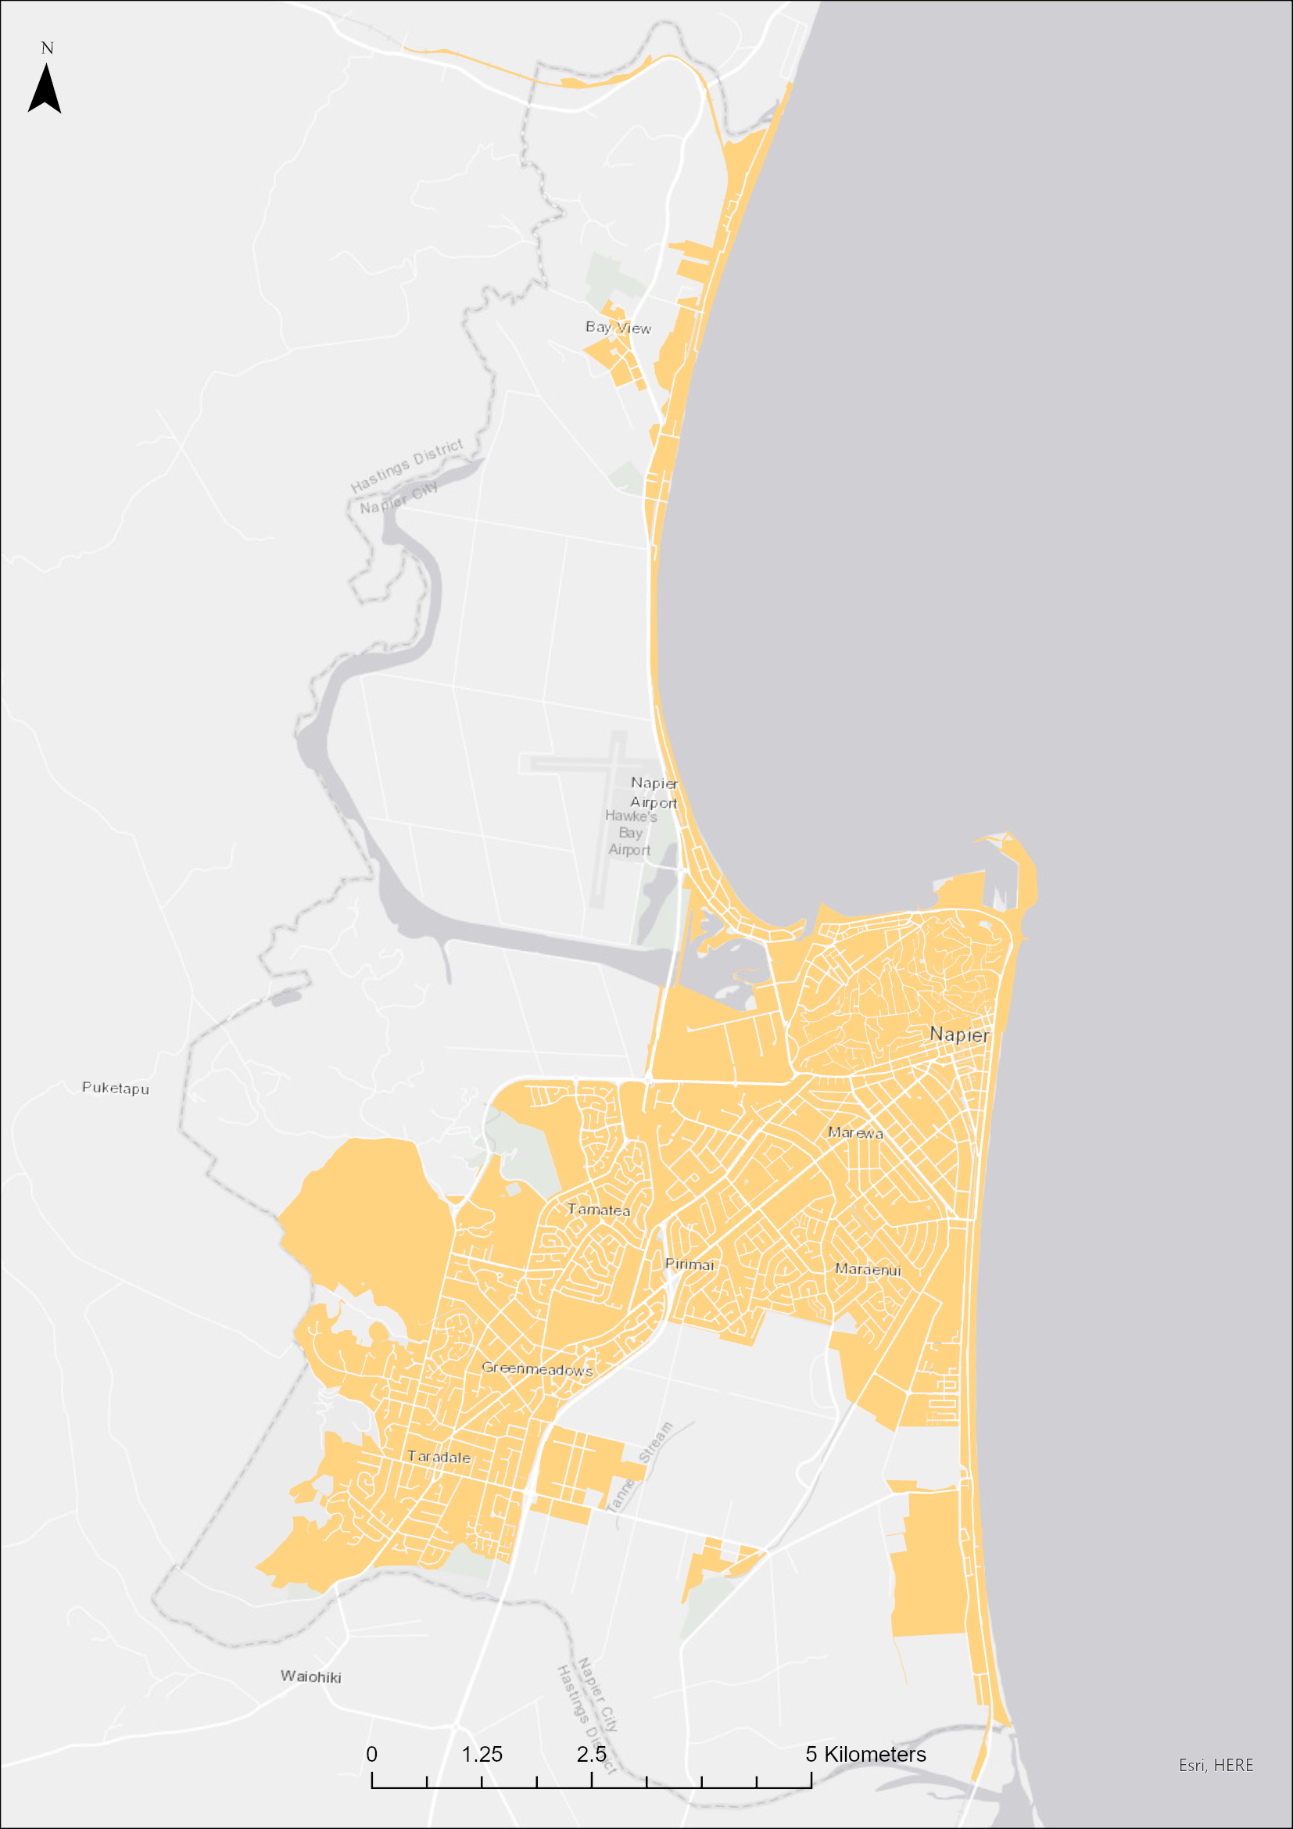

Policy Review
This policy will be reviewed at least once every three years.

